Midterm Exam

_____ _____ ____ ____ __________ ___

| ____| ____/ ___/ ___| |___ /___ / _ \

| _| | _|| | \___ \ |_ \ / / | | |

| |___| |__| |___ ___) | ___) |/ /| |_| |

|_____|_____\____|____/ |____//_/ \___/
EECS 370 Fall 2024: Introduction to Computer Organization

You are to abide by the University of Michigan College of Engineering Honor Code. Please sign below to signify that you have kept the honor code pledge:
I have neither given nor received aid on this exam,
nor have I concealed any violations of the Honor Code.
Signature: | ______________________________________________________________
Name: | ______________________________________________________________
Uniqname: | ______________________________________________________________
Uniqname of person sitting to your Right  (Write 丄 if you are at the end of the row) |  | __________________________________
Uniqname of person sitting to your Left  (Write 丄 if you are at the end of the row) |  | __________________________________

Exam Directions:
- You have 120 minutes to complete the exam. There are 7 questions in the exam on 16 pages (double-sided). Please flip through your exam to ensure you have all pages.
- Write legibly and dark enough for the scanners to read your answers.
- Write your uniqname on the line provided at the top of each page.
Exam Materials:
- You are allotted one 8.5 x 11 double-sided note sheet to bring into the exam room.
- You are allowed to use calculators that do not have an internet connection. All other electronic devices, such as cell phones or anything or calculators with an internet connection, are strictly forbidden.

Problem | 1 | 2 | 3 | 4 | 5 | 6 | 7
Point Value | 14 | 15 | 9 | 8 | 14 | 20 | 20

THIS PAGE INTENTIONALLY LEFT BLANK

Problem 1: Multiple Choice 14 points

Completely shade in the boxes with the best answer. Select only 1 answer unless specified otherwise. [1 point each]

- While _______ has largely stopped since the mid-2000s, _______ there have been ongoing efforts to keep _______ alive.
  - Moore's Law / Von Neuman's Law
  - Von Neumann's Law / Moore's Law
  - Dennard Scaling / Von Neuman's Law
  - Von Neumann's Law / Dennard Scaling
  - Moore's Law / Dennard Scaling
  - Dennard Scaling / Moore's Law

- LC2K is an example of a ______ architecture. (FILL IN ALL THAT APPLY)
  - RISC
  - CISC
  - Von Neumann
  - Single-instruction

- Which of the following is run at any time earlier than the linker in the build process? (FILL IN ALL THAT APPLY)
  - Assembler
  - Debugger
  - Compiler
  - Loader

- Which of the following values is stored in binary when the program is run?
int x = 107;
int y = 0x13A;
  - Neither x nor y
  - x, but not y
  - y, but not x
  - x and y

- Recalling that a float uses 8 bits for the exponent and 23 bits for the significand, the difference between 1.25*2³ and the next largest value that can be represented exactly as a single precision floating point value is:
  - 2⁻²³
  - 2⁻²²
  - 2⁻²¹
  - 2⁻²⁰
  - 1.25*2⁻²³
  - 1.25*2⁻²²
  - 1.25*2⁻²¹
  - 1.25*2⁻²⁰
- Which of the following best describes why beq instructions don't need to go in the relocation table for project 2a?
  - Branches do not access anything in memory
  - The address of a branch's target can be resolved before the linking stage
  - The distance between a branch and its target will not change during linking
  - Branch targets can use hard coded offsets rather than labels

- Instructions are placed in the _______ section of memory
  - Stack
  - Heap
  - Static
  - Executive
  - Text

- When compiling C to assembly, the first element of a struct is aligned in memory based off: (FILL IN ALL THAT APPLY)
  - the size of the smallest primitive in the struct
  - the size of the largest primitive in the struct
  - the total size of the struct, not including arrays or nested structs
  - the total size of the struct, including arrays or nested structs

- Compared to the number of instructions listed in an assembly file, the number of instructions executed when run is guaranteed to be:
  - smaller
  - smaller or equal
  - larger
  - larger or equal
  - none of the above (could be smaller, greater or equal)

- Which of the following elements below are universal (i.e. can be used to implement any other logical operation) (FILL IN ALL THAT APPLY)
  - NOT
  - AND
  - OR
  - NAND
  - NOR
  - XOR

Problem 2: Short Answers 15 points

- Convert each of the 8-bit hexadecimal numbers into its binary form and decimal form (both for treating the original number as a signed (two's-complement) and an unsigned value). [3 points]
Hexadecimal | Binary | Decimal (signed) | Decimal (unsigned)
0x7A | 0111 1010 | 122 | 122
0x9E | 1001 1110 | -98 | 158

- For each element of the struct below, list out the starting and ending (inclusive) addresses in hex, assuming address 0x1000 is the first address available and it is run on a 64-bit architecture with datatype sizes included in the reference material: [5 points]

struct {
int a;
long int b[3];
char c;
struct {
char d_1;
int d_2;
char d_3;
} d;
short* e;
} my_struct;

Element | Starting address (hex) | Ending address (hex)
a | 0x1000 | 0x1003
b | 0x1008 | 0x101F
c | 0x1020 | 0x1020
d | 0x1024 | 0x102F
e | 0x1030 | 0x1037

- Complete the timing diagram below for (1) a D latch, (2) a rising-edge triggered D flip-flop, and (3) an XOR gate whose output is 1 ns delayed from any input changes. If a value is unknown given the information, indicate that clearly using the notation shown. Assume there is no meaningful delay within the components of the D latch or flip-flop. In the case of the latch, “C” is the Gate input. [3 points]

Value unknown
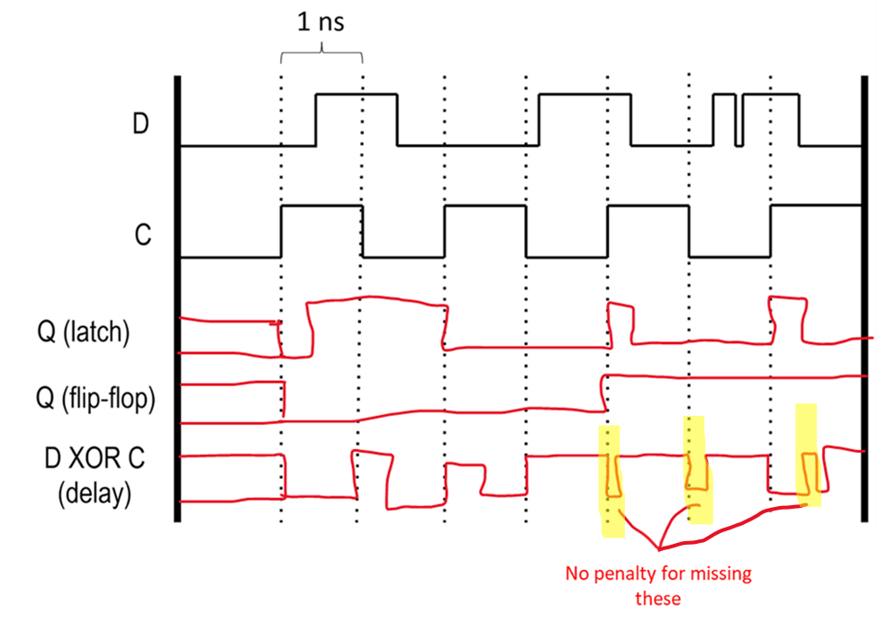
- Show the final value of the memory and registers listed after the following LEGv8 code runs. You are to assume that all registers and any memory value not shown are initialized to be zero. Assume we are in little endian mode. Put all answers in hex. [4 points]

Memory location | Initial value | Final value (in hex)
100 | 0x13 | 0x13
101 | 0x0F | 0x0F
102 | 0xF2 | 0xF2
103 | 0xCA | 0xCA
104 | 0x90 | 0x00
105 | 0x33 | 0x00
106 | 0x7B | 0x13
107 | 0x20 | 0x0F
LDURSW X0, [XZR, #100]
STURW X1, [XZR, #104]
STURH X0, [XZR, #106]
LDURSW X1, [XZR, #104]

Reg | Value
X0 | 0xFFFFFFFFCAF20F13
X1 | 0x0F130000

Problem 3: Bench(mark) Warmer 9 points

Consider two implementations of an ISA.
Single cycle design:
- Clock period of 15ns
- Cycles per instruction:
Instruction | Cycles
All instructions | 1 cycle
Multi-cycle design:
- Clock period of 1ns
- Cycles per instruction:
Instruction | Cycles
Add | 5 cycles
Branch | 6 cycles
Load and store | 7 cycles

The a 1 million instruction program is run with the following distribution:
Instruction | Percentage
Add | 30%
Branch | 20%
Load and store | 50%

- What is the execution time (in milliseconds) of the program on the single-cycle design? Write your final answer in the box and show all work. Recall 1 second = 1000 milliseconds = 1 billion nanoseconds [4 points]

1 million * 15 ns / (1 million ns per ms) = 15 ms

15 ms

- What is the execution time (in milliseconds) of the program on the multi-cycle design? Write your final answer in the box and show all work [5 points]

1 million * (.3 * 5 + .2 * 6 + .5 * 7) * 1 ns / (1 million ns per ms) = 6.2 ms

6.2 ms

Problem 4: Caller/Callee Save 8 points
Count the number caller/callee-save pairs executed for each variable when driver() is called once. Assume the compiler checks for liveness across function calls but does not make any other optimizations.
void driver( void ){  int x=2, y=3;  printf("Starting"\n);  x = x + 1;  y = x – 3;  for(int i=0;i<4;i++){  buddy();  }  return;  } | void buddy( void ){  int j=0;  printf("In function\n");  if(j != j){  j++;  printf("Uh-oh\n"); }  j++;  return;  }

Variables | Caller load/store pairs | Callee load/stores pairs
x | 1 | 1
y | 0 | 1
i | 4 | 1
j | 4 | 4

Problem 5: Assembling and Linking 14 points

- We’ve tried to link and assemble our two LC-2K assembly files, but it looks like some of the data got corrupted in one of them. Fill in the blank of the object file. (Note: the object file is shown starting a line earlier to allow the relevant parts of assembly to line up) [14 points]

eecs.as |  | eecs.obj
lw 0 3 Loc  lw 0 2 Lst  beq 0 2 Done  jalr 3 7  Done halt  Lst .fill 6  .fill 2  .fill 1  .fill 7  Size .fill 3  Loc .fill Func | 0  1  2  3  4  5  6  7  8  9  10  11  12  13  14  15  16  17  18 | 5 6 5 3  0x0083000A  0x00820005  0x01020001  0x015F0000  0x01800000  0x6  0x2  0x1  0x7  0x3  0x00000000  Done T 4  Lst D 0  Size D 4  Loc D 5  Func U 0  0 lw Loc  1 lw Lst  5 .fill Func

Problem 6: ARM Assembly 20 points

Fill in the blanks to complete the following C-to-LEGv8 assembly conversion. You may not define any other labels. Assume we are following the ARM ABI discussed in class (see reference material), and assume that the call stack grows downwards in memory as items are placed on the stack (i.e. memory addresses get smaller as more items are added to the stack). Remember that LEGv8 is a 64-bit system.

int helper(int x);  int data[8]; // assume array  // starts at address  // 1000  void proc(int n) {  int j = n * 9;  while(helper(j) < 10) {  j += 1;  }  data[j % 8] = j;  return;  } | proc:  subi x28, x28, #8  stur x30, [x28, #0]  lsl x1, x0, #3  add x0, x0, x1  while:  subi x28, x28, #4  sturw x0, [x28, #0]  bl helper  cmpi x0, #10  ldursw x0, [x28, #0]  addi x28, x28, #4  b.ge end  addi x0, x0, #1  b while  end:  andi x1, x0, #7  lsl x1, x1, #2  sturw x0, [x1, #1000]  ldur x30, [x28, #0]  addi x28, x28, #8  br x30

Problem 7: Big Macc 20 points
A common instruction in many ISAs is "multiply-accumulate" (MACC), in which a destination register is incremented by the product of two other registers, i.e.
destReg = destReg + regA * regB
Assume we replace our jalr instruction with MACC, encoding it as an R-Type instruction (destReg in bits 2-0, source regs in 21-19 and 18-16). We build a multi-cycle datapath, performing the steps below for each cycle for MACC:
Cycle | MACC Actions
1 | Fetch instruction, calculate next PC
2 | Start calculation, update PC
3 | Finish calculation
4 | Write back result
Assume a full memory cycle is needed to read an instruction from memory, but unlike in lecture, a register value can be read and used on the same cycle.
- On the datapath below, add the connections, along with any hardcoded 1s or 0s, needed to support MACC. Any connections needed for other LC2K instructions but not MACC will lose points if included. You may not add any other muxes or other components, and you do not need to show control signals. [10 points]
Notes:
- All muxes (labeled A-D) are 2-inputs
- "MULT" calculates the product of its two inputs using combinational logic
- All other components are as described in lecture
- Place a clear dot on any crossing lines which should be connected. Crossing lines without a dot will be assumed to be unconnected.
- In any instance where a multi-bit signal is split into different groups of signals, you must label which bits are which by placing an inclusive number range above each line
- Two copies of the datapath are provided. Place a large 'X' through the copy you do not want graded.
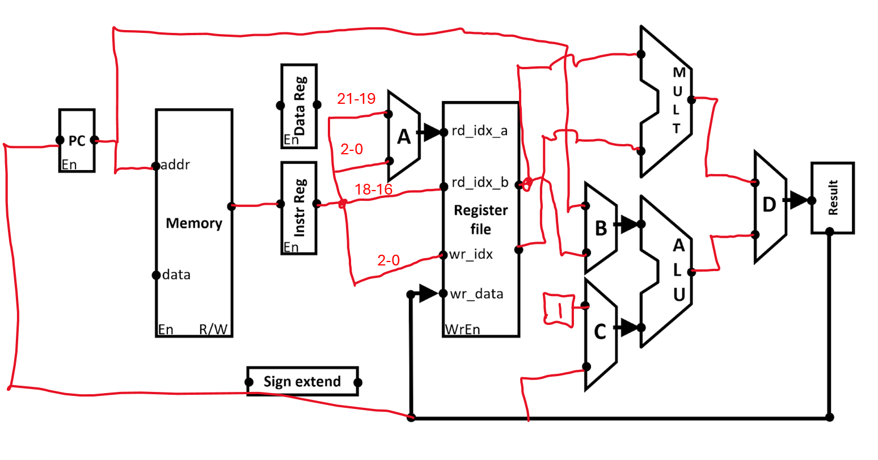
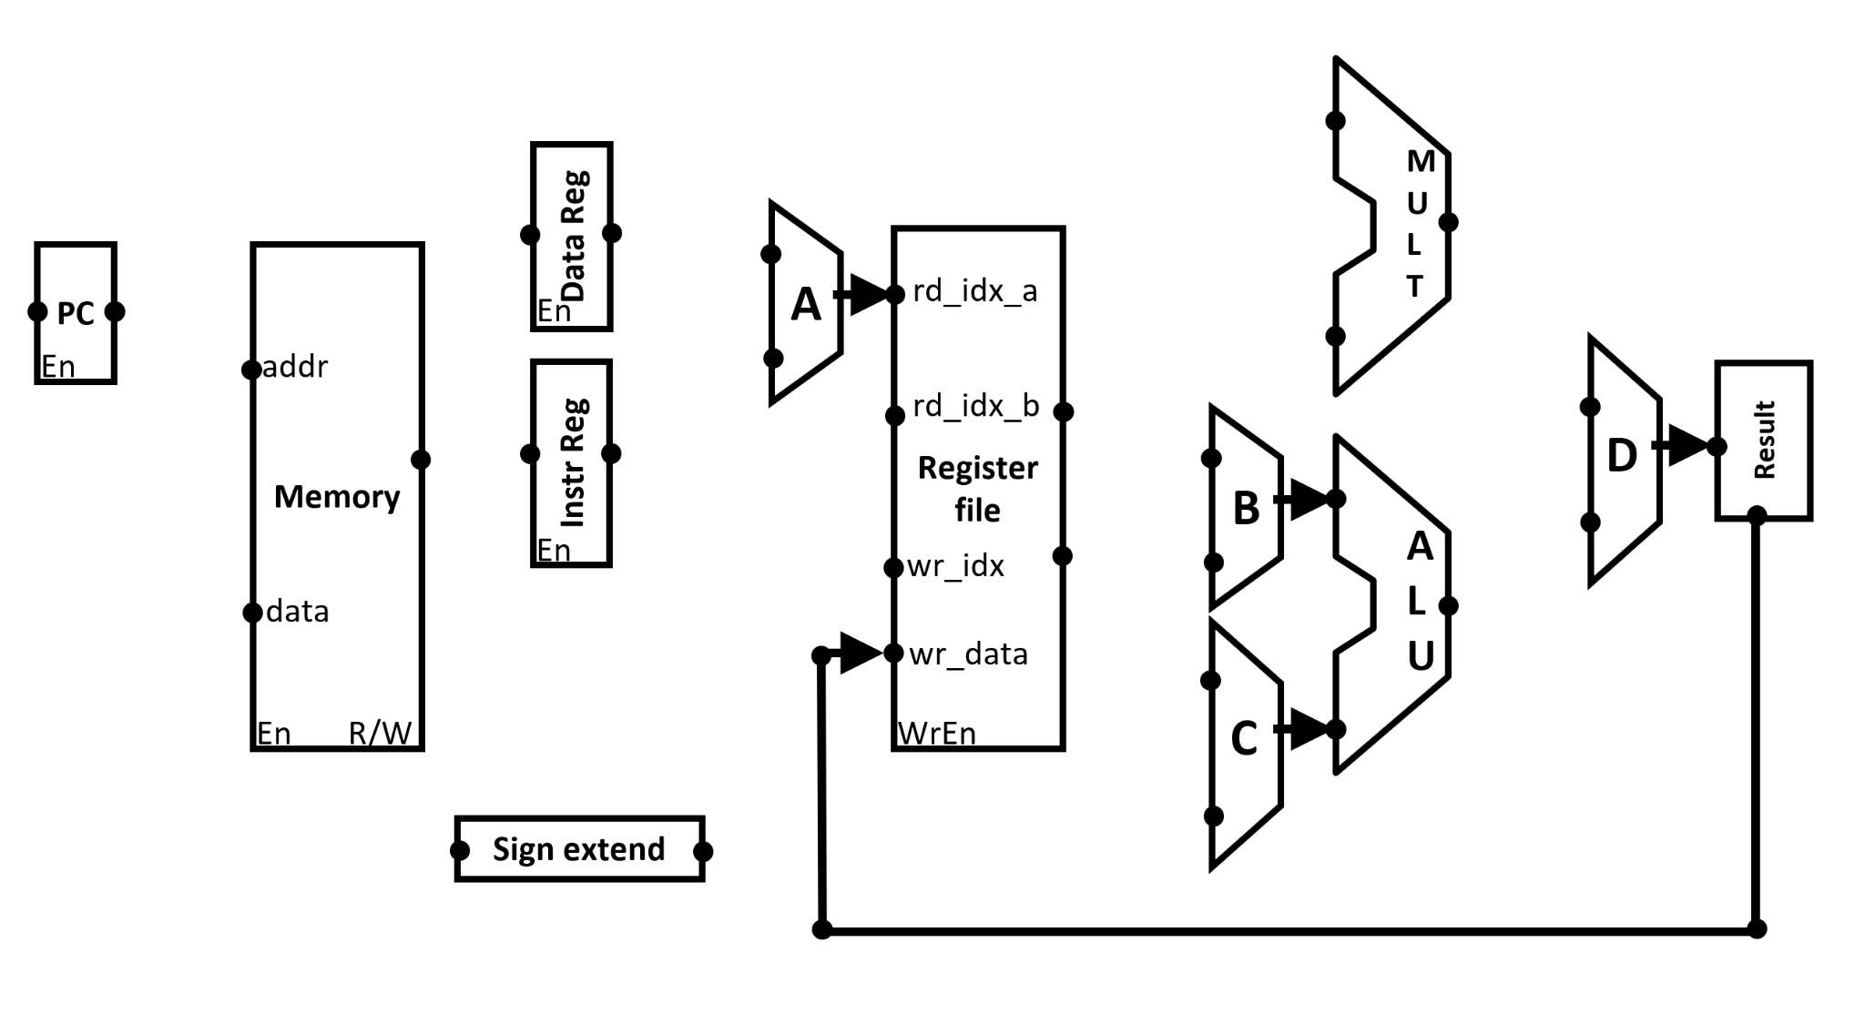
- List the control signals needed to implement each of the 4 cycles for MACC below. Any control signals whose values don't matter must be listed as "X". The description of each cycle is copied below for reference [10 points]

Cycle | MACC Actions
1 | Fetch instruction, calculate next PC
2 | Start calculation, update PC
3 | Finish calculation
4 | Write back result

Cycle | PC _{en} | Mem _{en} | Mem _{R/W} | DataReg _{en} | InstReg _{en} | muxA _{sel} | RegFile _{WrEn} | muxB _{sel} | muxC _{sel} | ALU _{op} | muxD _{sel}
1 | 0 | 1 | 0 | 0/X | 1 | X | 0 | 0 | 0 | 0 | 1
2 | 1 | 0 | X | 0/X | 0 | 0 | 0 | X | X | X | 0
3 | 0 | 0 | X | 0/X | 0 | 1 | 0 | 1 | 1 | 0 | 1
4 | 0 | 0 | X | 0/X | 0 | X | 1 | X | X | X | X
Muxes could be different, based on wiring
DataReg_en will be 1 on cycle 2 if using instead of "Result"
(or 1 on cycle 1 if using to hold result of PC+1)

